Assignment no. 02

Q.1 Write a program to print unit digit of a given number

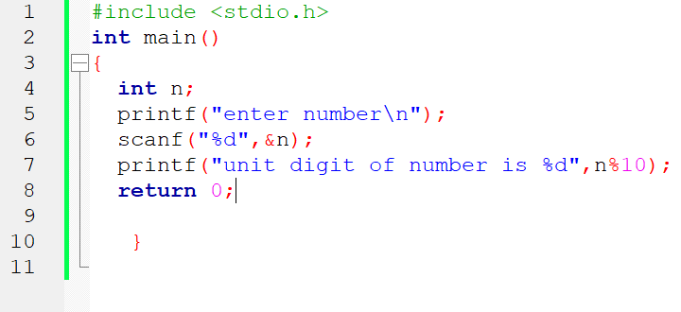

Q.2 Write a program to print a given number without its last digit.

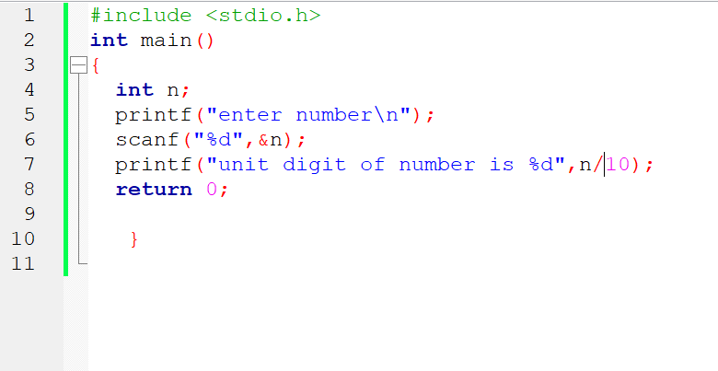

Q.3 Write a program to swap values of two int variables



Q.4 Write a program to swap values of two int variables without using a third variable.

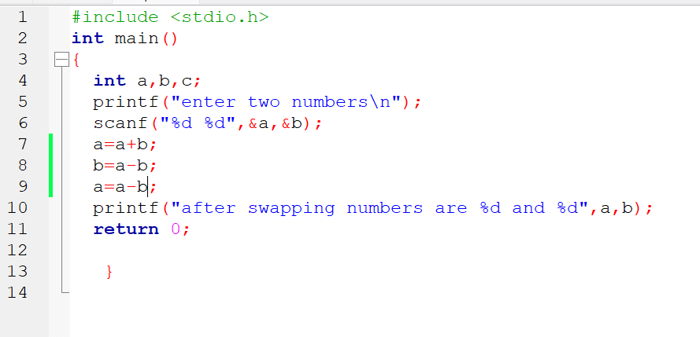

Q.5 Write a program to input a three-digit number and display the sum of the digits.

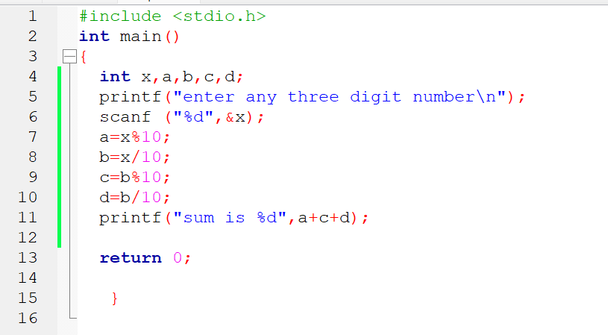

Q.6 Write a program which takes a character as an input and displays its ASCII code.

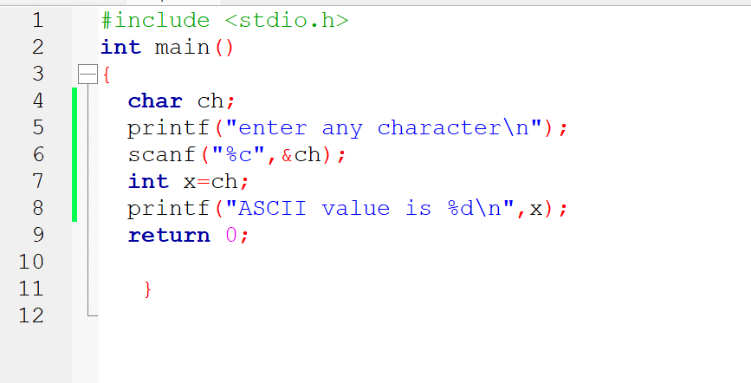

Q.7 Write a program to find the position of first 1 in LSB.

--

Q.8 Write a program to check whether the given number is even or odd using a bitwise operator.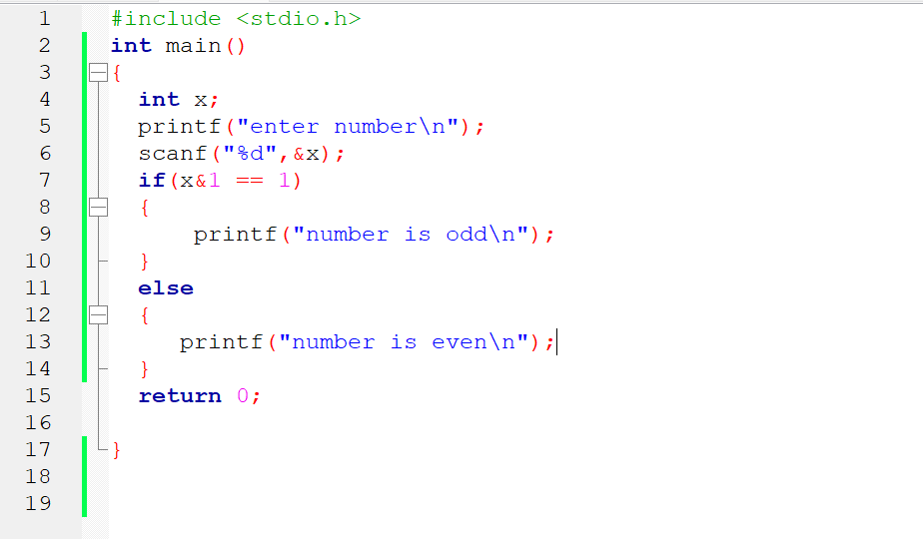

Q.9 Write a program to print size of an int, a float, a char and a double type variable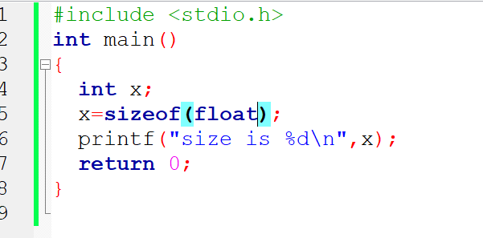

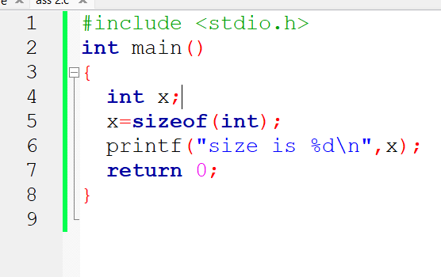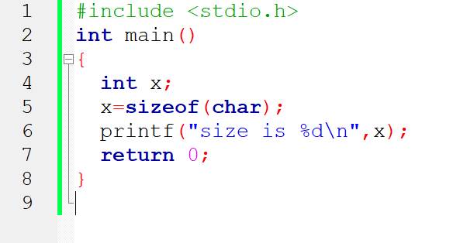

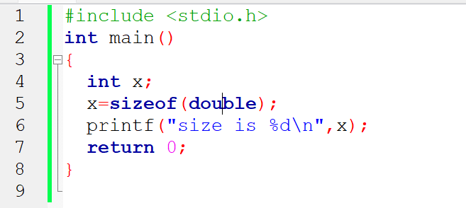

Q.10 Write a program to make the last digit of a number stored in a variable as zero.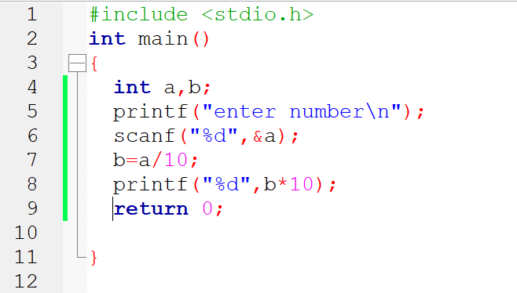

Q.11 Write a program to input a number from the user and also input a digit. Append a digit in the number and print the resulting number.

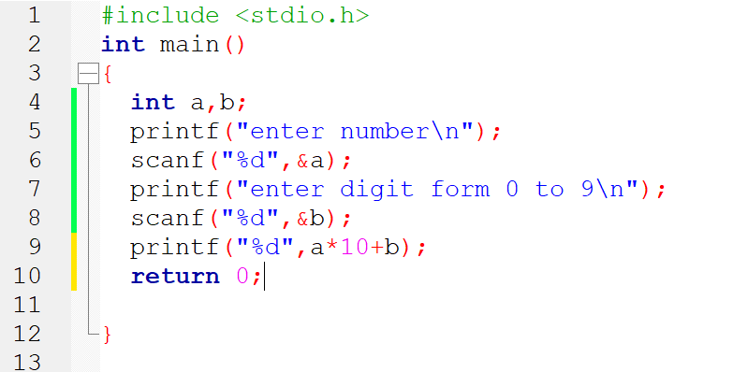

Q.12 Assume price of 1 USD is INR 76.23. Write a program to take the amount in INR and

convert it into USD.

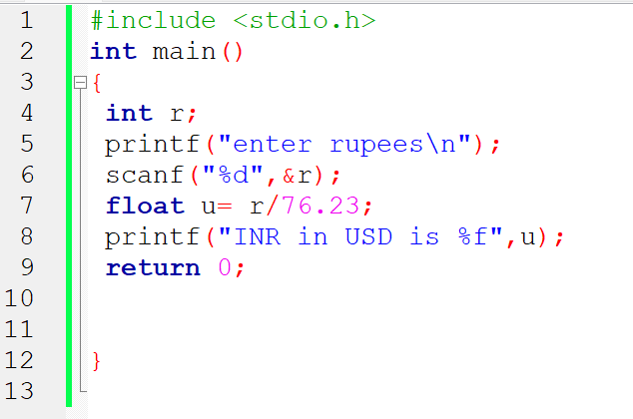

Q. 13 Write a program to take a three-digit number from the user and rotate its digits by

one position towards the right.

---